**kubeADM:**

<https://www.edureka.co/blog/install-kubernetes-on-ubuntu>

<http://www.joseluisgomez.com/containers/kubernetes-dashboard/>

Create master machine and node machine in aws

**In master and node**

$sudo su

# apt-get update

# swapoff -a

# nano /etc/hostname

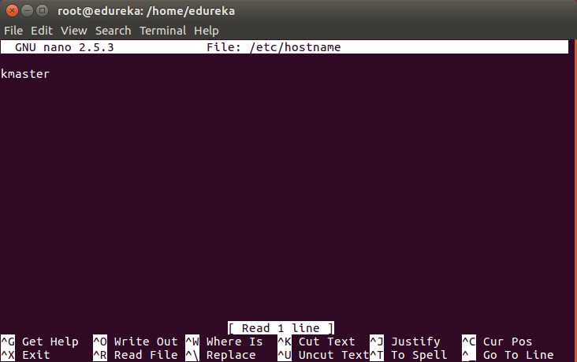

nano /etc/hosts

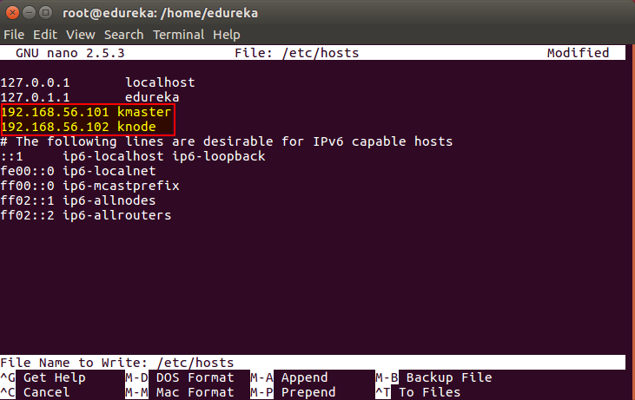

# nano /etc/network/interfaces

auto enp0s8

iface enp0s8 inet static

address <IP-Address-Of-VM>

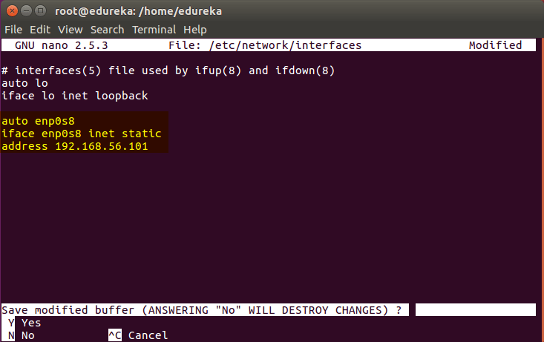

# sudo apt-get install openssh-server

# sudo su

# apt-get update

# apt-get install -y docker.io

# apt-get update && apt-get install -y apt-transport-https curl

# curl -s https://packages.cloud.google.com/apt/doc/apt-key.gpg | apt-key add -

# cat <<EOF >/etc/apt/sources.list.d/kubernetes.list

deb http://apt.kubernetes.io/ kubernetes-xenial main

EOF

# apt-get update

# apt-get install -y kubelet kubeadm kubectl

# nano /etc/systemd/system/kubelet.service.d/10-kubeadm.conf

Environment=”cgroup-driver=systemd/cgroup-driver=cgroupfs”

## environment variables - install kubernetes - edureka

## Steps Only For Kubernetes Master VM (kmaster)

# kubeadm init --apiserver-advertise-address=<ip-address-of-kmaster-vm> --pod-network-cidr=192.168.0.0/16

1. You will get the below output. The commands marked as (1), execute them as a non-root user. This will enable you to use kubectl from the CLI
2. The command marked as (2) should also be saved for future. This will be used to join nodes to your cluster

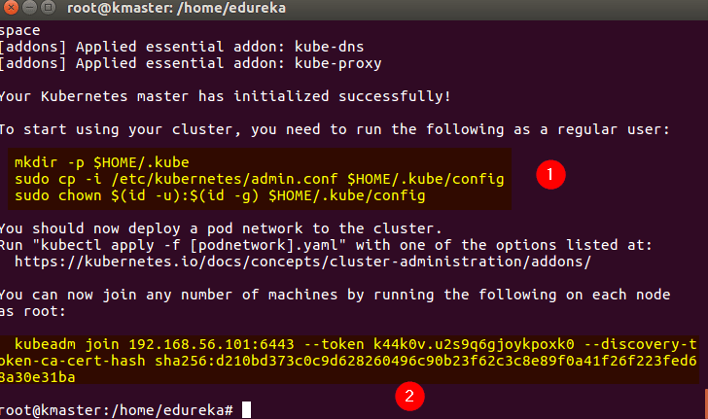

mkdir -p $HOME/.kube

$ sudo cp -i /etc/kubernetes/admin.conf $HOME/.kube/config

$ sudo chown $(id -u):$(id -g) $HOME/.kube/config

 kubectl get pods -o wide --all-namespaces

**we should copy the token and join the node.we should put the token in node machine.**

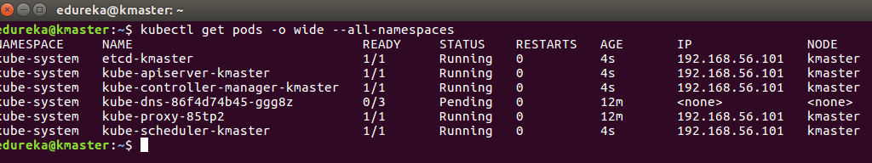

**For calico**

**kubectl apply -f https://docs.projectcalico.org/v3.3/getting-started/kubernetes/installation/hosted/rbac-kdd.yaml**

**kubectl apply -f https://docs.projectcalico.org/v3.3/getting-started/kubernetes/installation/hosted/kubernetes-datastore/calico-networking/1.7/calico.yaml**

**for running dashboard**

kubectl apply -f https://raw.githubusercontent.com/kubernetes/dashboard/v1.10.1/src/deploy/recommended/kubernetes-dashboard.yaml

**for checking dashboard running**

kubectl -n kube-system get pod

**for edit node port**

**$**kubectl -n kube-system edit service kubernetes-dashboard

**For find port number**

$ kubectl -n kube-system get service kubernetes-dashboard

**Then open dashboard in mozilla firefox**

[**https://private**](https://private) **ip of vm:port number**

**kubeadm get nodes->for checking if it is ready or not**

**kubectl get service -l app=tomcat->get port of app**

**services:**

**kubectl create -f tomcat.yaml**

**kubectl create -f tomcat-service-lb.yaml**

**kubectl get service -l app=tomcat**

**kubectl describe service service-name(tomcat-loadbalanceservice)**

**kubectl delete service service name**

kubectl expose deployment hello-world --**type=LoadBalancer** **--name=my-service**

**kubelet get service**

**The connection to the server localhost:8080 was refused - did you specify the right host or port?**

sudo kubeadm init --pod-network-cidr=192.168.0.0/16  
mkdir -p $HOME/.kube  
sudo cp -i /etc/kubernetes/admin.conf $HOME/.kube/config  
sudo chown $(id -u):$(id -g) $HOME/.kube/config

and then run

sudo kubectl apply -f https://docs.projectcalico.org/v3.1/getting-started/kubernetes/installa